Om Gupta (EXT)

[Company name]  [Company address]

UAT-BPD Documentation PRE-Upgrade

Index

**1] UAT-BPD Version 3**

**2] Home** 4

**3] Blueprints** 4

**3.1] bookmarked 4**

**3.2] Internal-Team** 5

3.2.1] Ashwani 5

3.2.2] project1 6

3.2.3] SOLO-LINUX 6

3.2.4] SOLO-WINDOWS **7**

3.2.5]SQL_CLUSTER-WIN 7

3.2.6]Test_run 8

3.2.7] UCD-AEP-MASTER8

3.2.8] UCD-AEP-MASTER-MOD9

3.2.9] VM-CREATE-LINUX **9**

3.2.10] VM-Folder-Creation 10

3.2.11] VM-Folder-Creation-Test 10

3.2.12] Windows 11

**4] Environments** 11

Terraform-UAT (TERRAFORM) **11**

**5] Repositories** 12

**6] Settings** 14

**6.1] Users** 14

**6.1.1] Internal Authentication** 14

6.1.1.1] Users **15**

6.1.1.2] Groups 15

6.1.1.3] Edit 16

**6.2] Roles** 16

6.2.1] Admin16

6.2.2] Blueprint Manager **17**

6.2.3] Environment Manager 17

6.2.4] Observer 18

6.2.5] Participant 18

6.2.6] QA Manager19

**6.3] Teams** 19

**6.3.1] Internal Team** 19

6.3.1.1] MembersCloud **19**

6.3.1.2] ConnectionsOrchestration20

6.3.1.3] Connections 20

**6.4] Orchestrations** 20

6.4.1] Terraform-UAT 20

**6.5] Cloud Connections** **21**

6.5.1] ALPHA-NON-WEBLOGIC 21

6.5.2]vALPHA-WEBLOGIC 21

6.5.3] BRAVO-NON-WEBLOGIC 22

6.5.4] BRAVO-WEBLOGIC 23

6.5.5] CHARLIE-NON-WEBLOGIC 23

6.5.6] CHARLIE-WEBLOGIC 24

6.5.7] DELTA-NON-WEBLOGIC 24

6.5.8] DELTA-WEBLOGIC25

**6.6] Modules** 25

**6.7] System Settings** **26**

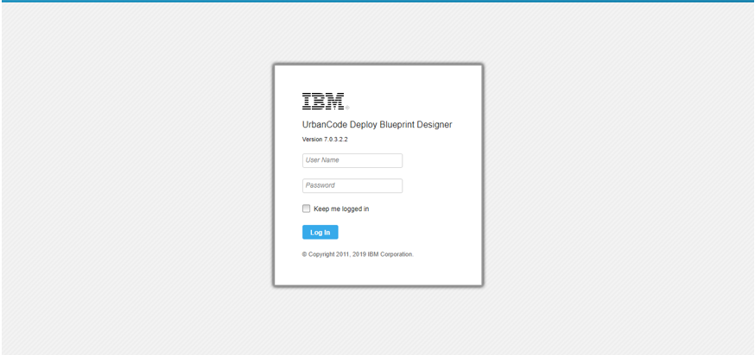

**1] UAT-BPD Version :**

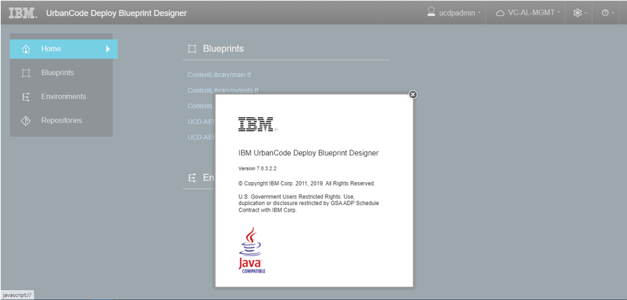

**2] Home**

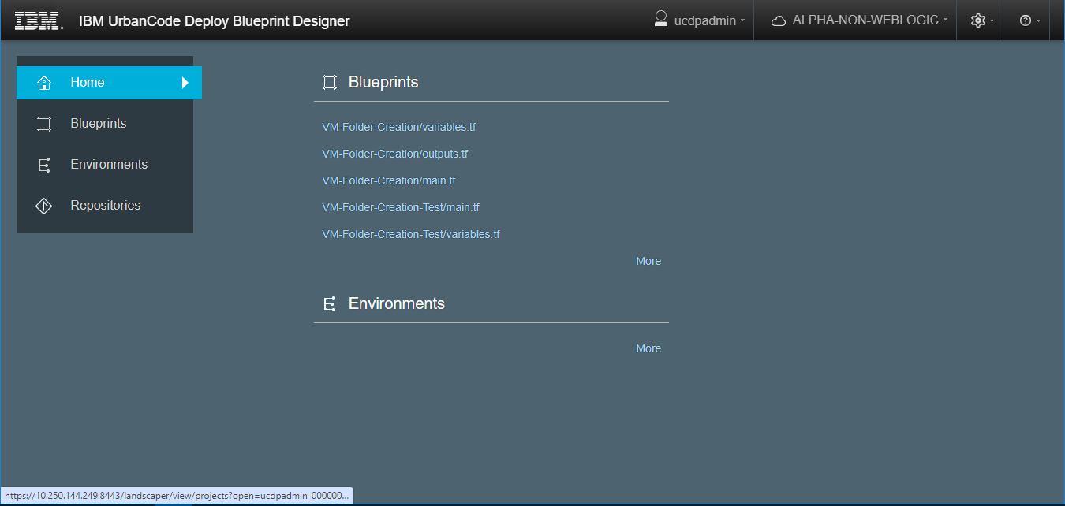

**3] Blueprints :**

**3.1] bookmarked**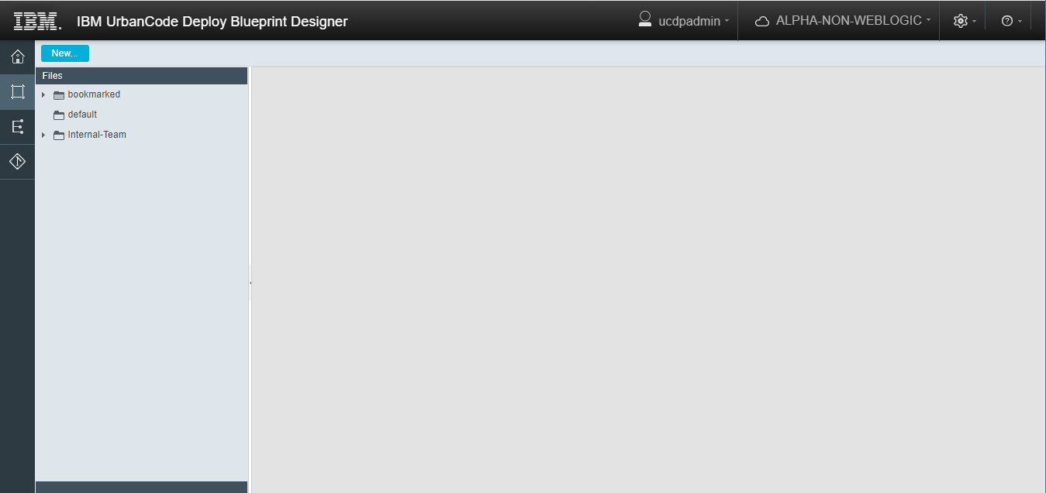

**3.2] Internal-Team**

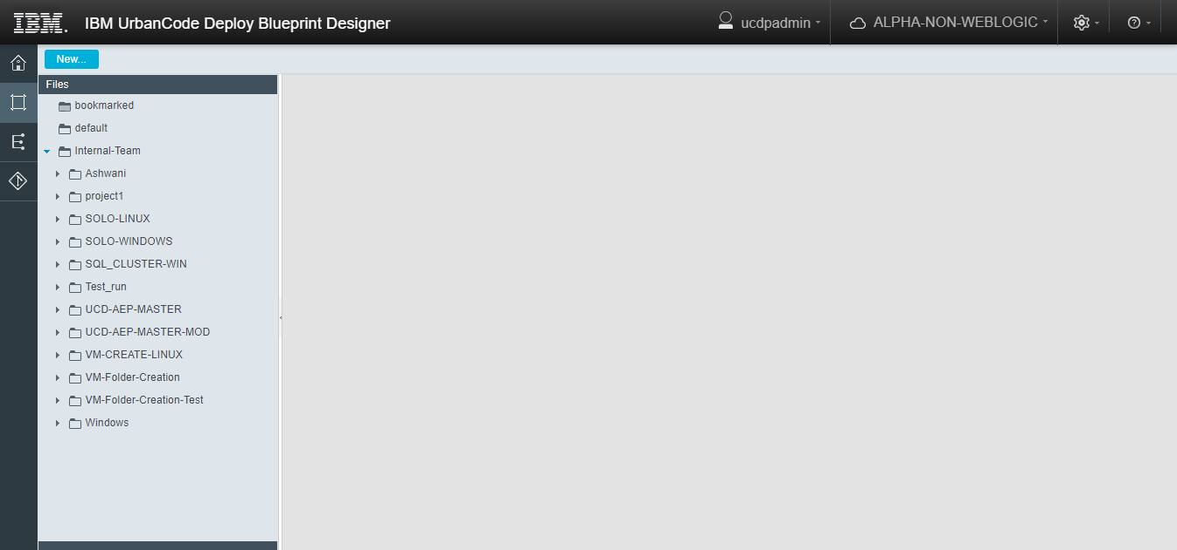

**3.2.1] Ashwani**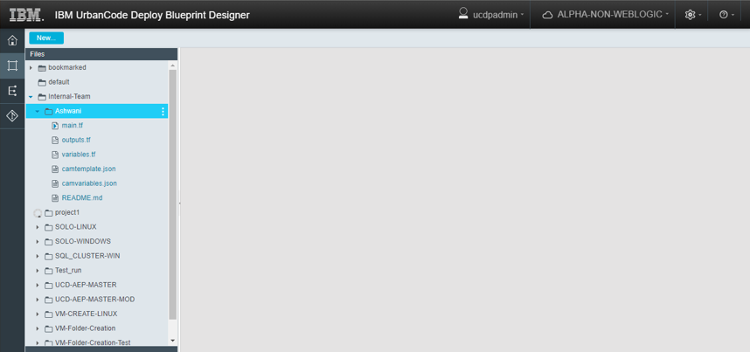

**3.2.2] project1**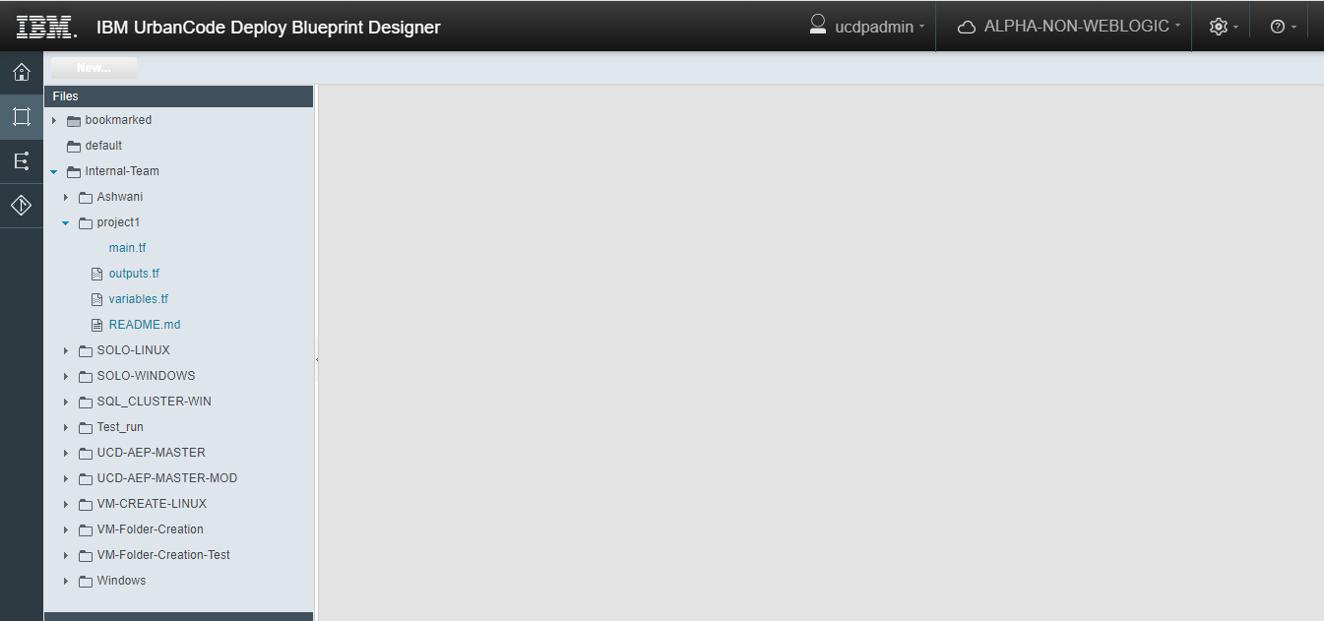

**3.2.3] SOLO-LINUX**

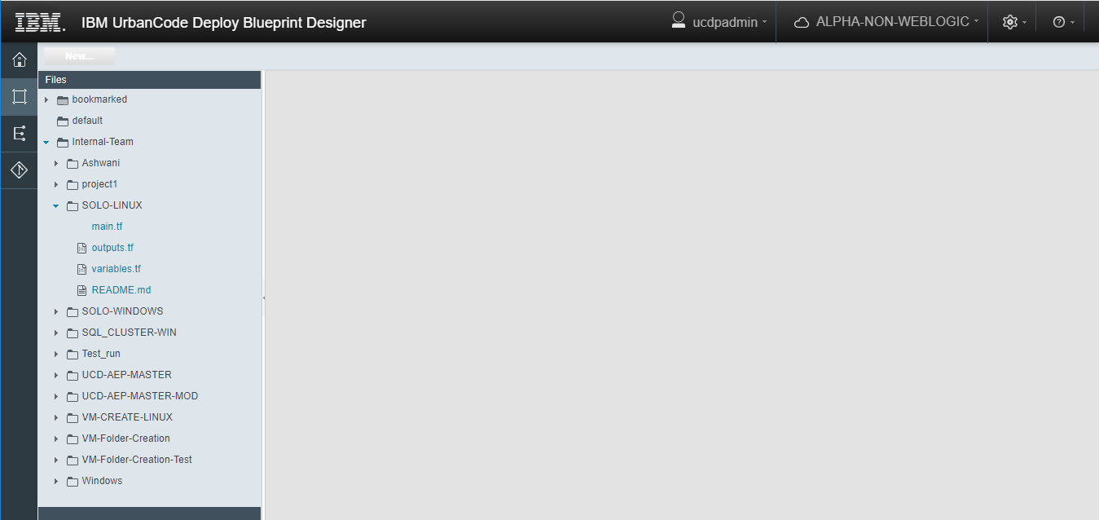

**3.2.4] SOLO-WINDOWS**

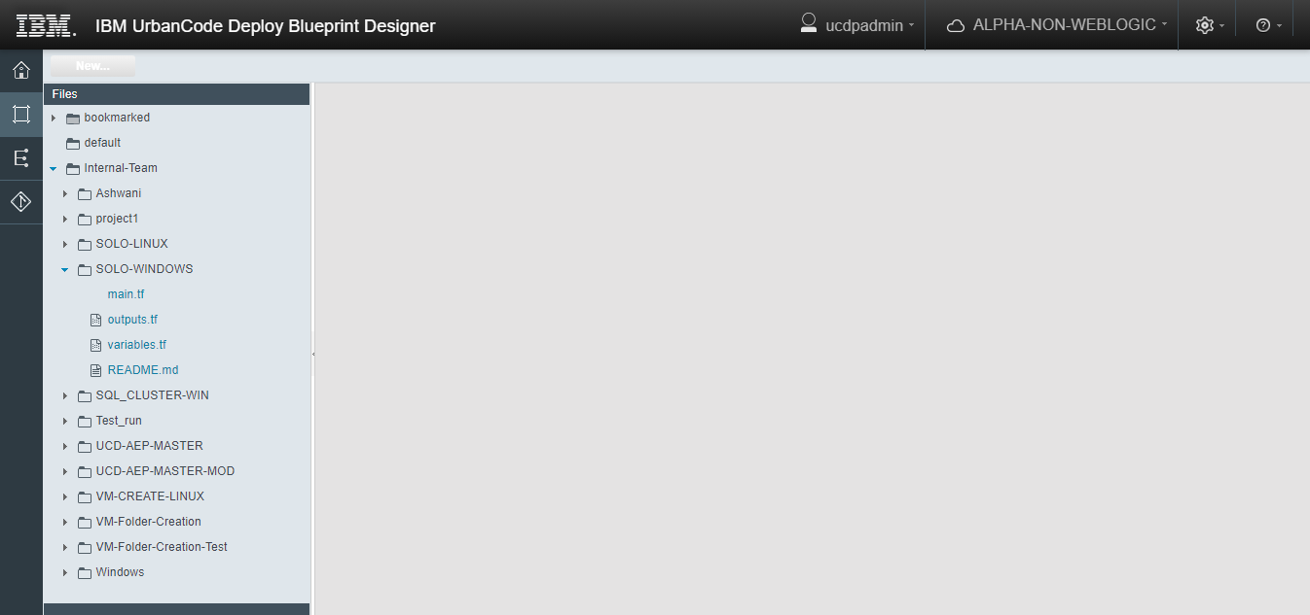

**3.2.5]SQL_CLUSTER-WIN**

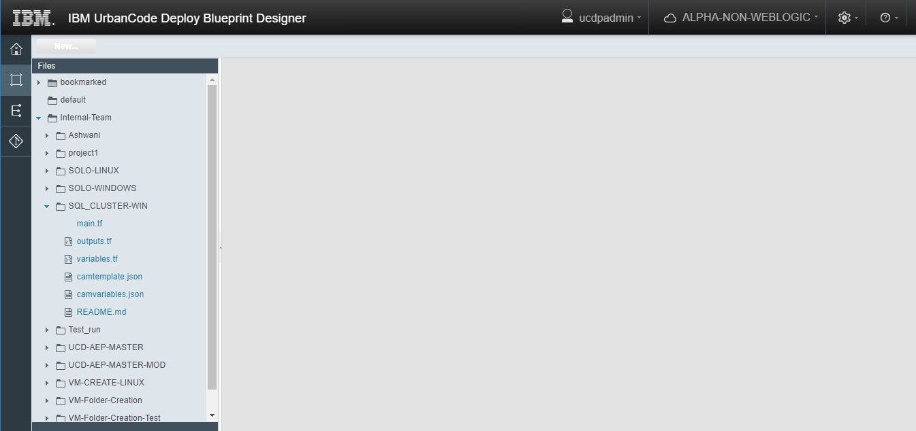

**3.2.6]Test_run**

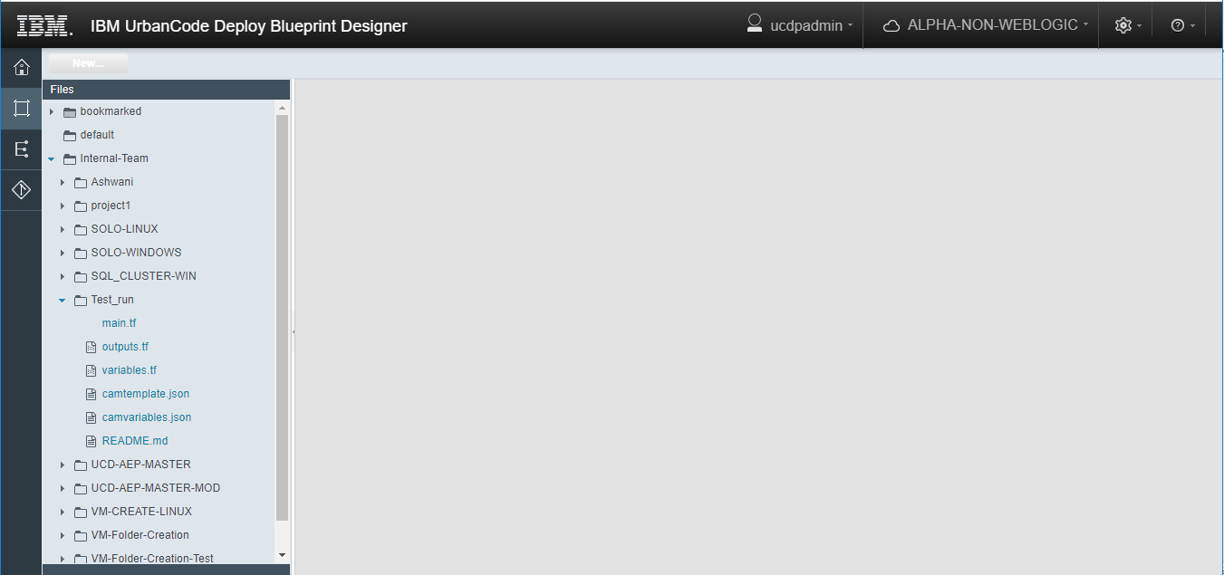

**3.2.7] UCD-AEP-MASTER**

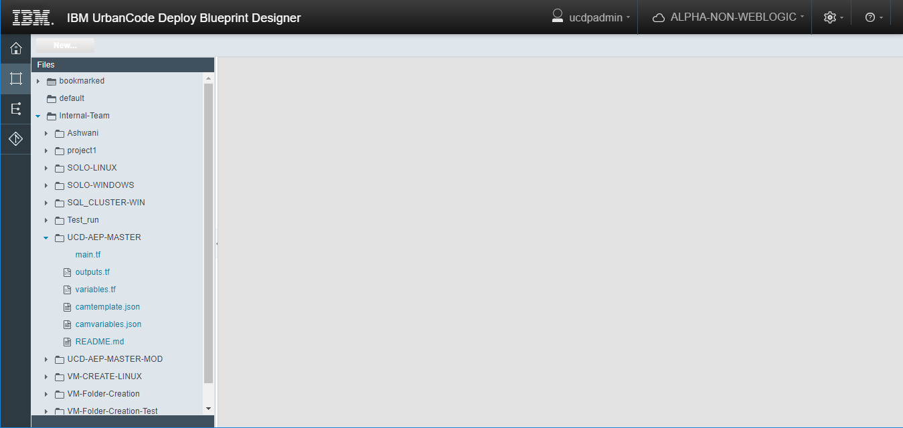

**3.2.8] UCD-AEP-MASTER-MOD**

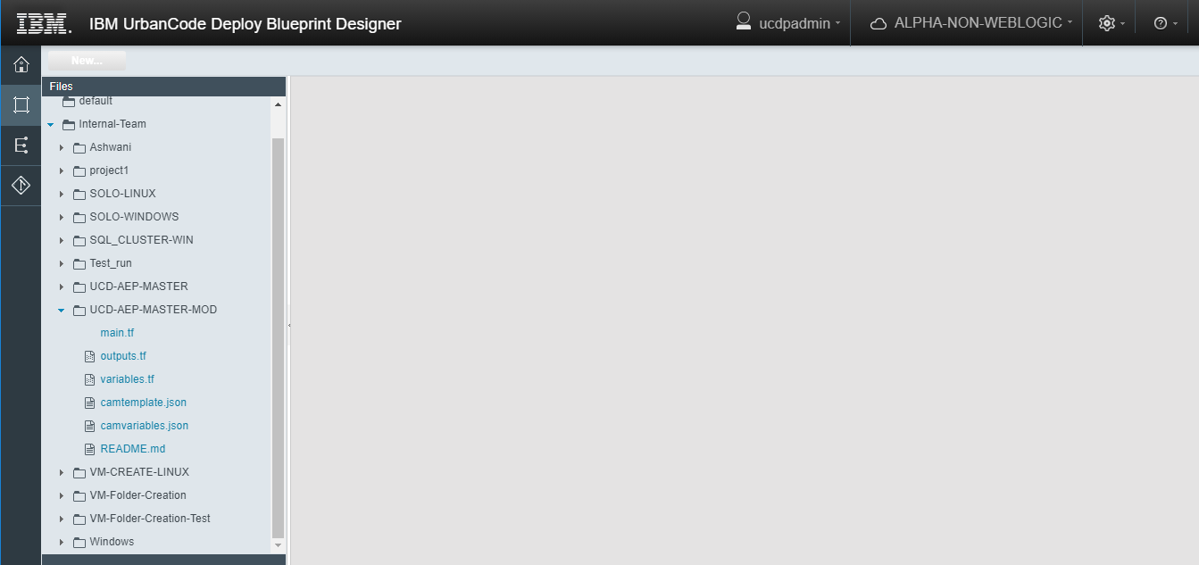

**3.2.9] VM-CREATE-LINUX**

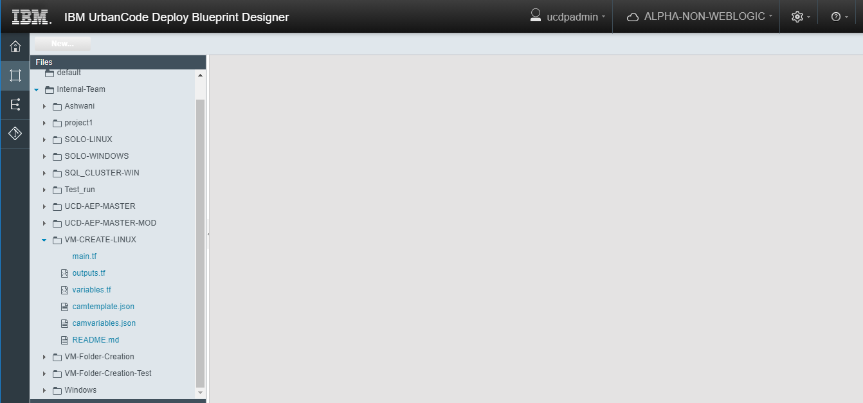

**3.2.10] VM-Folder-Creation**

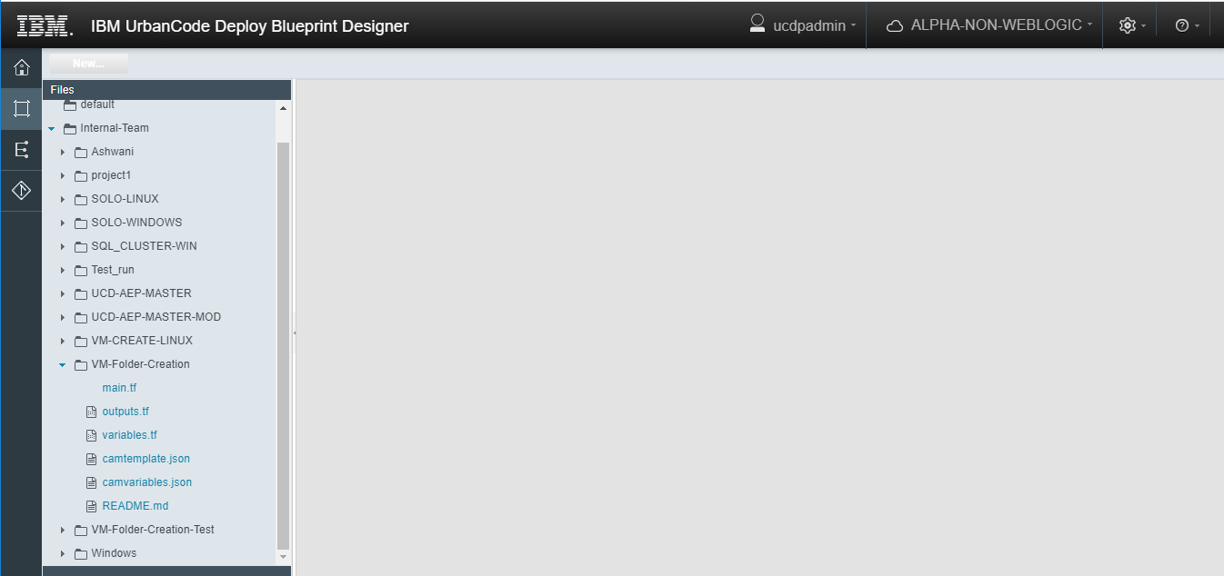

**3.2.11] VM-Folder-Creation-Test**

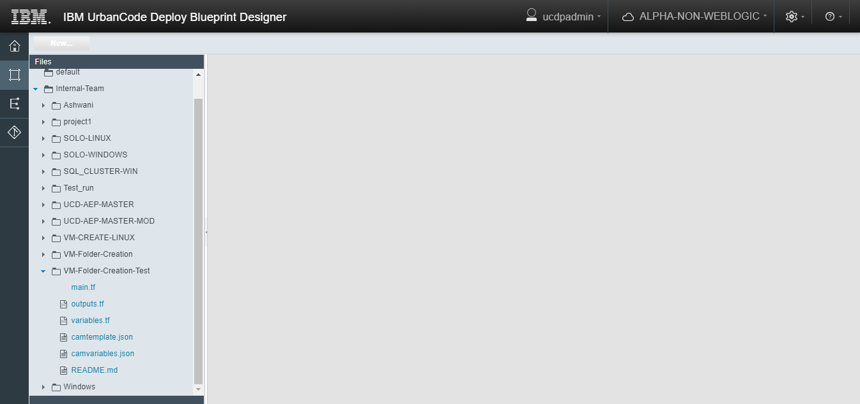

**3.2.12] Windows**

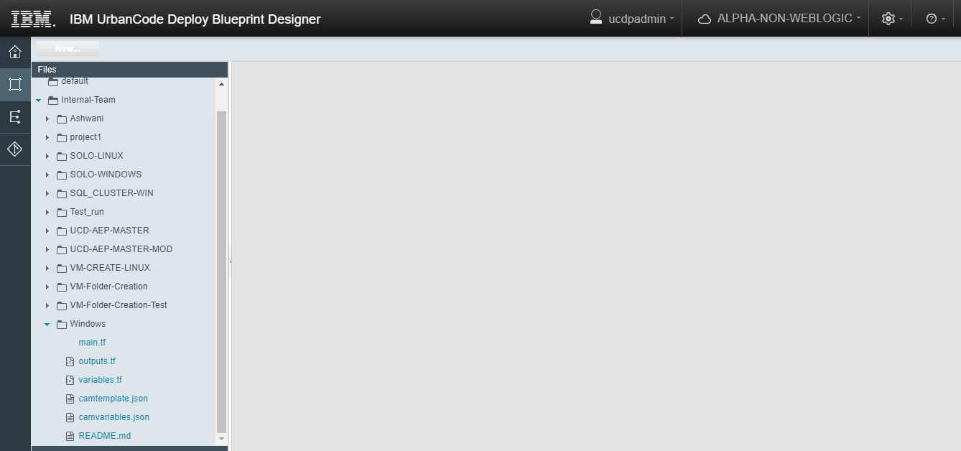

**4] Environments :**

**Terraform-UAT (TERRAFORM) :**

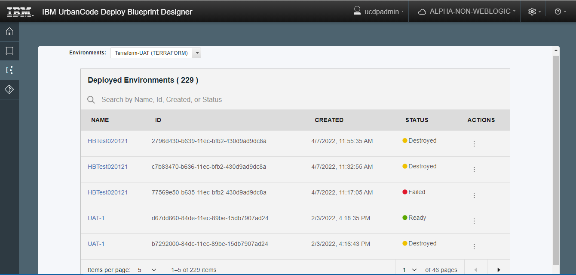

**Records= 229 Items.**

**5] Repositories :**

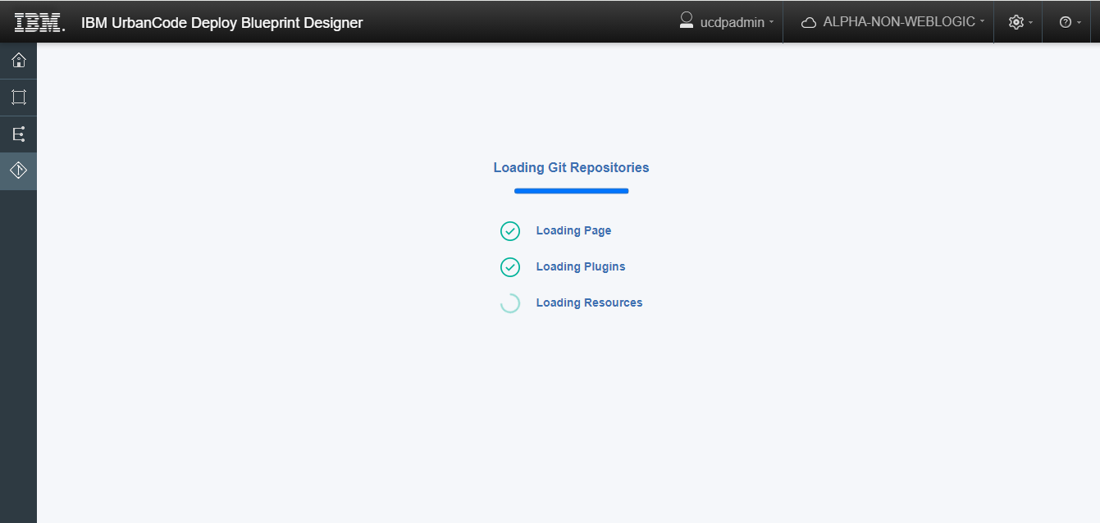

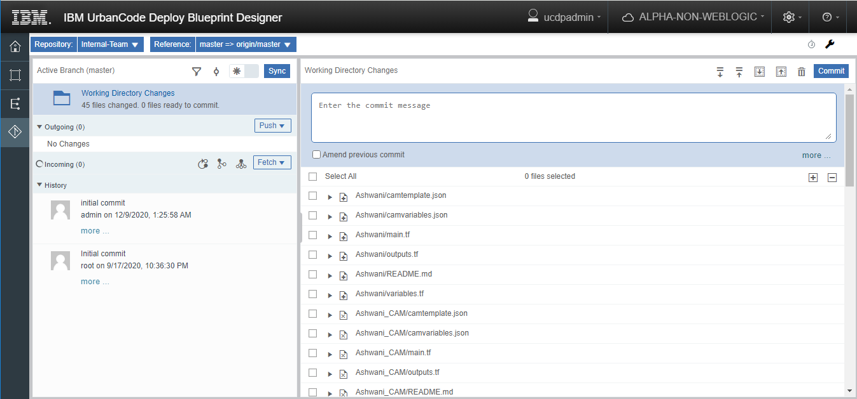

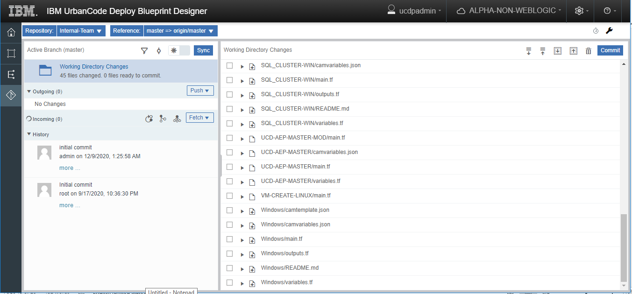

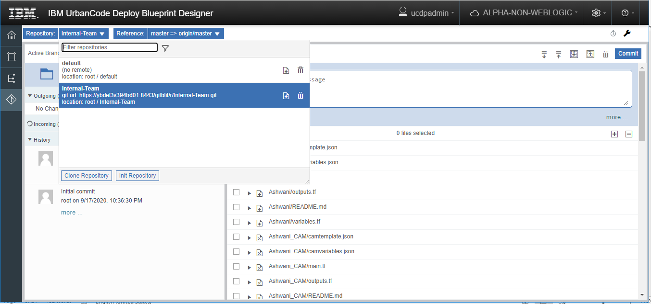

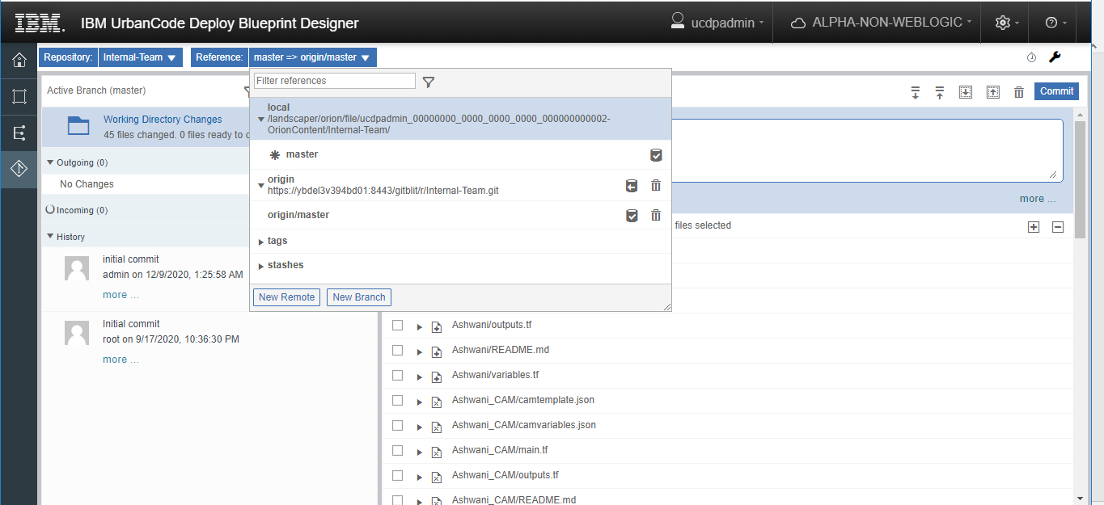

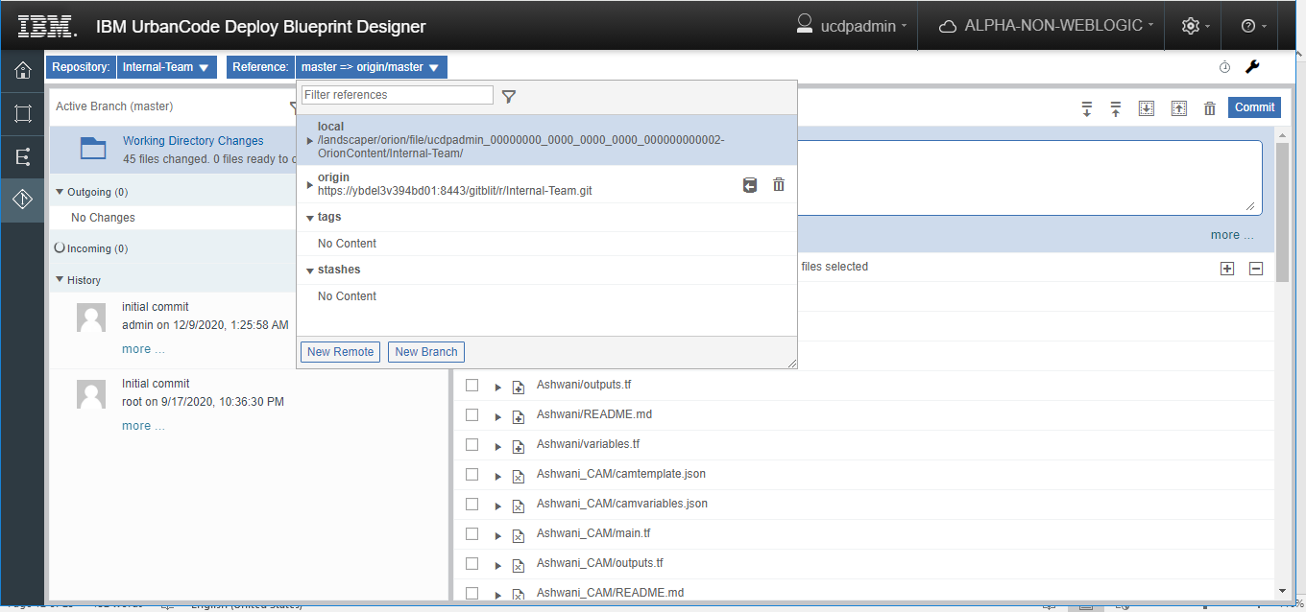

**6] Settings**

**6.1] Users :**

**6.1.1] Internal Authentication**

**6.1.1.1] Users**

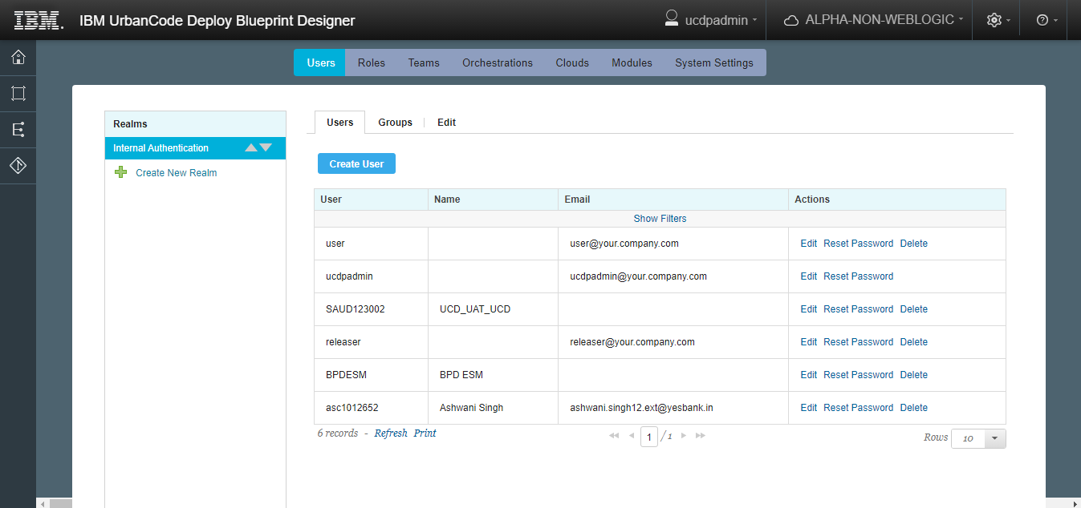

**Records =6**

**6.1.1.2] Groups**

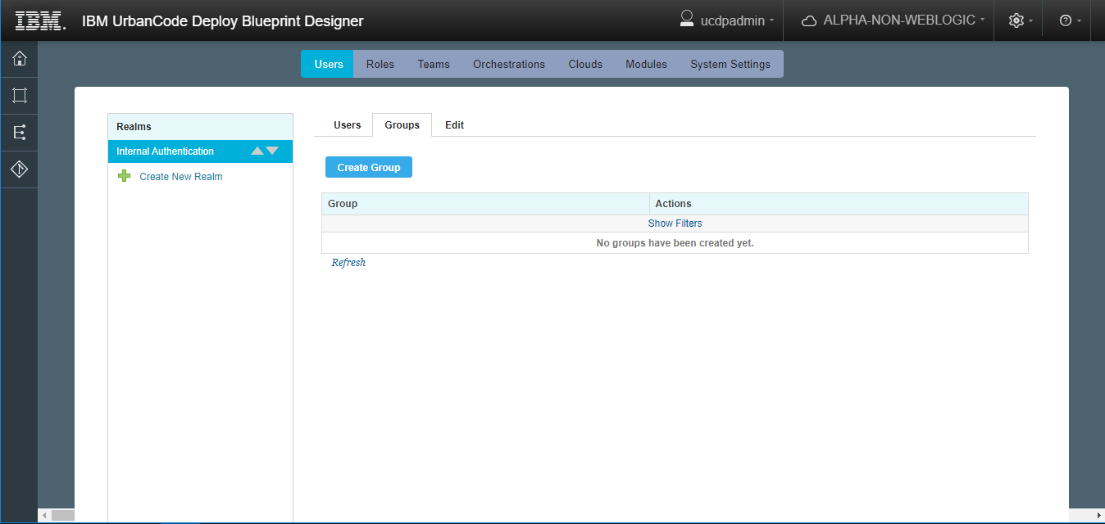

**Records= 0**

**6.1.1.3] Edit**

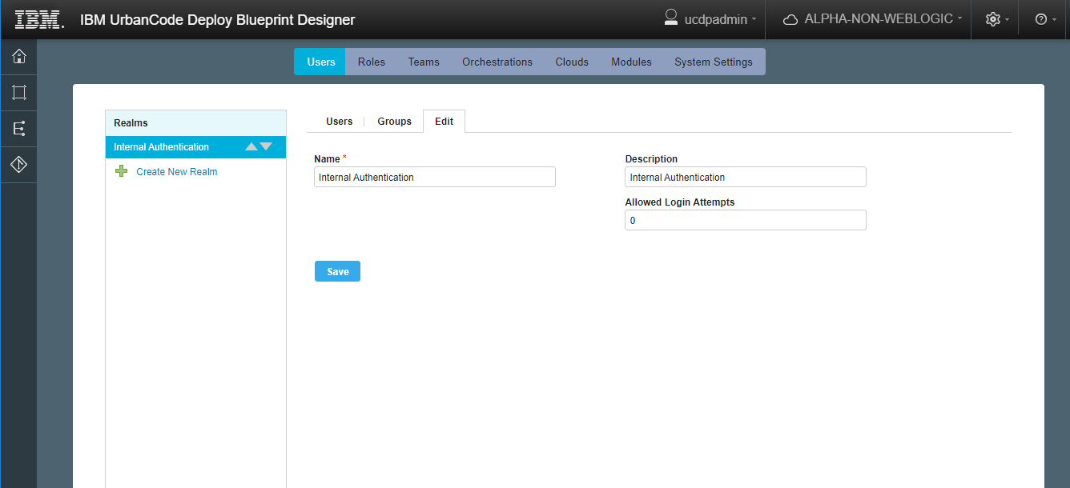

**6.2] Roles :**

**6.2.1] Admin**

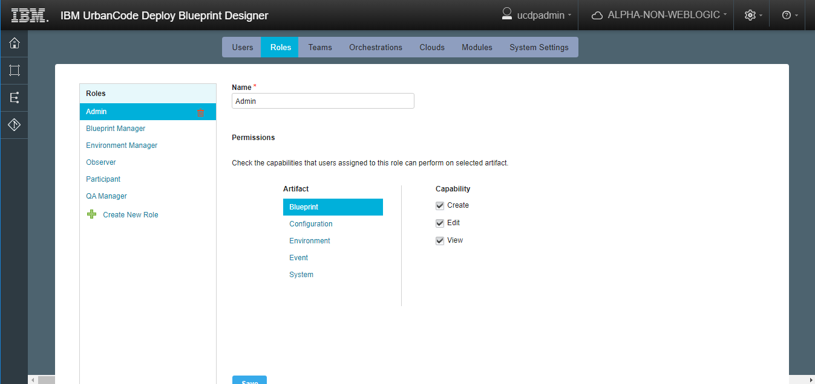

**6.2.2] Blueprint Manager**

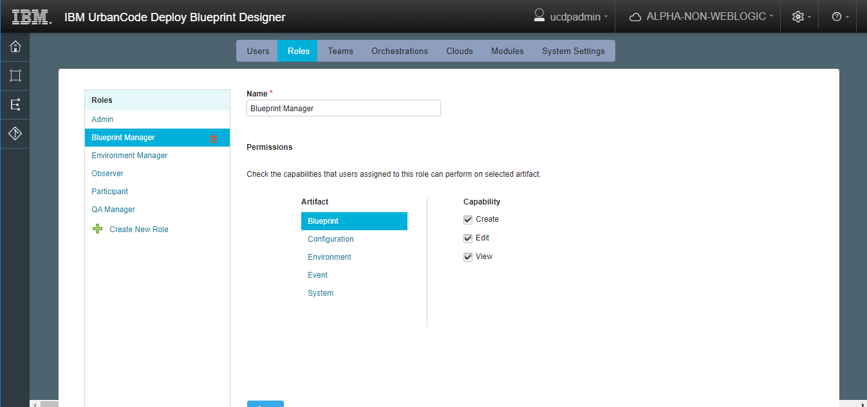

**6.2.3] Environment Manager**

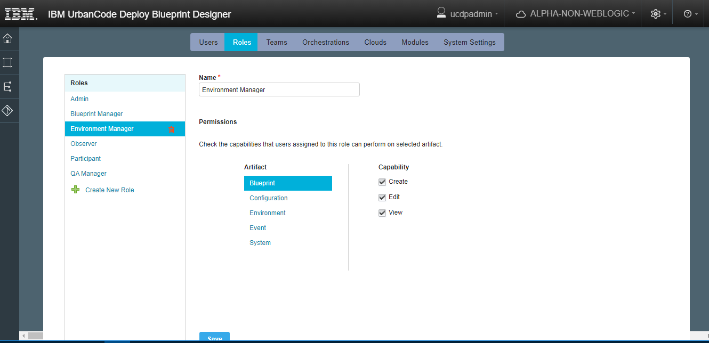

**6.2.4] Observer**

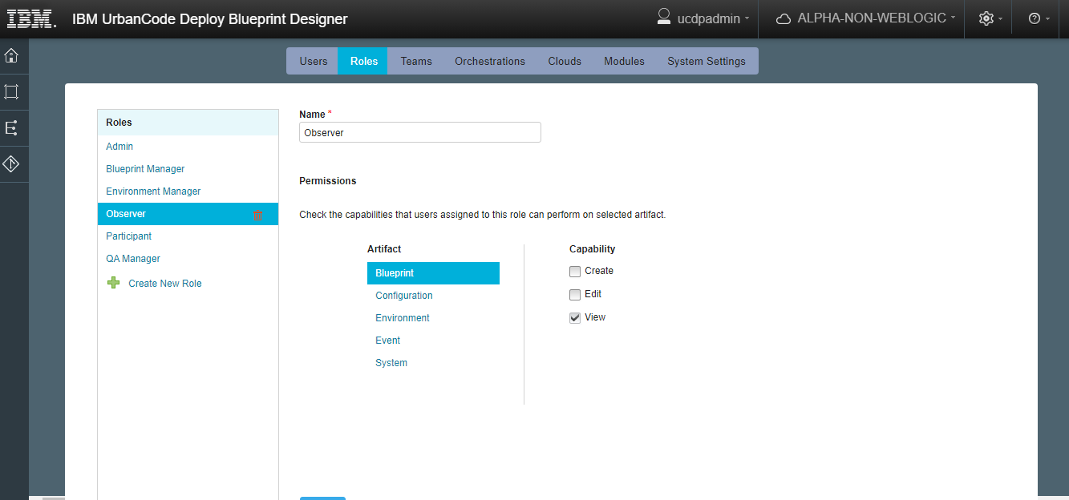

**6.2.5] Participant**

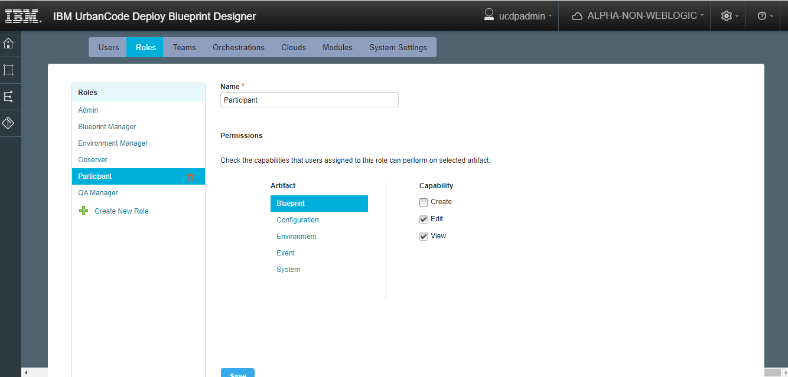

**6.2.6] QA Manager**

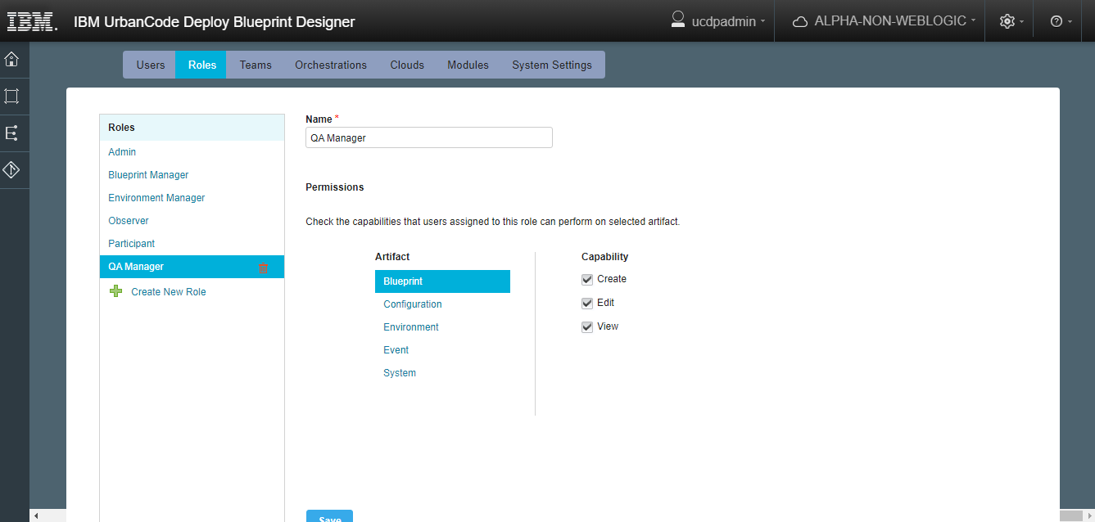

**6.3] Teams**

**6.3.1] Internal Team**

**6.3.1.1] MembersCloud**

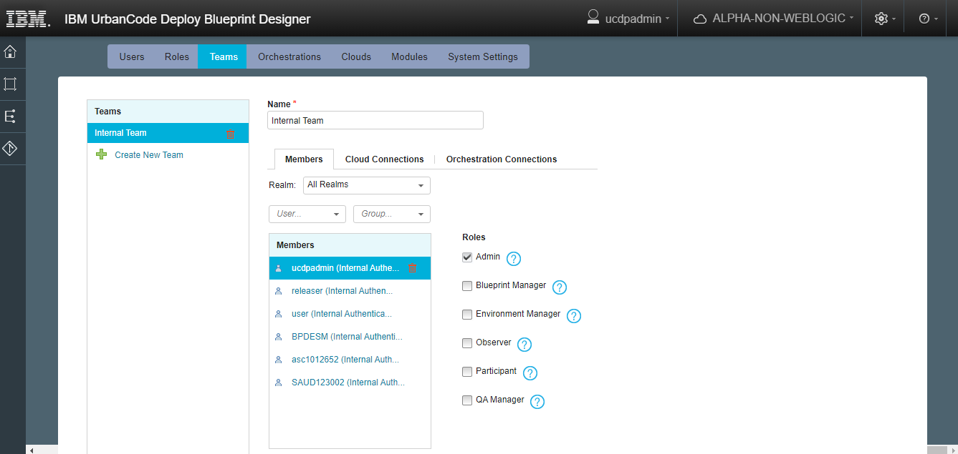

**6.3.1.2] ConnectionsOrchestration**

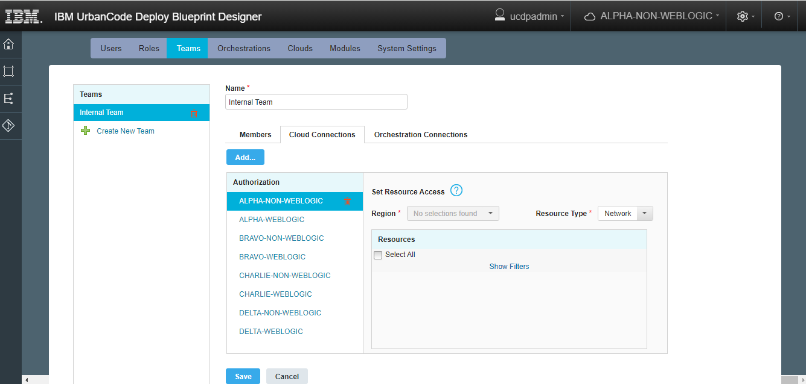

**6.3.1.3] Connections**

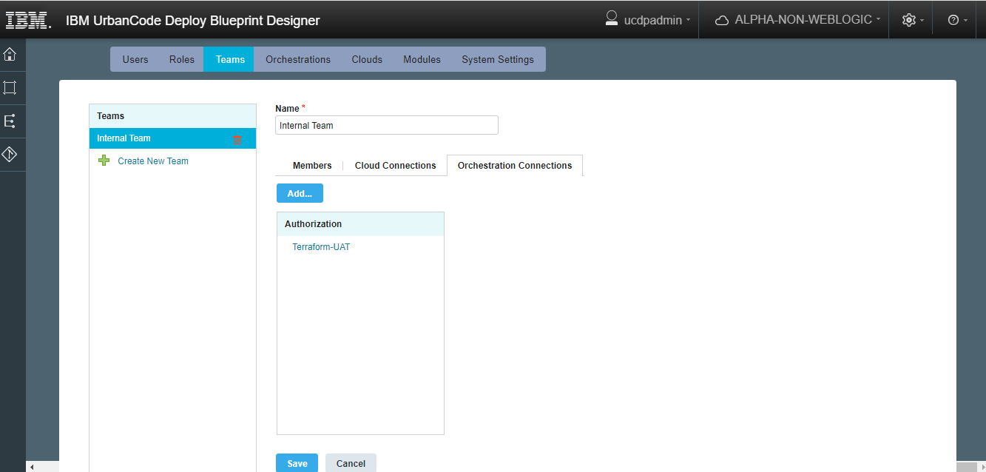

**6.4] Orchestrations**

**6.4.1] Terraform-UAT**

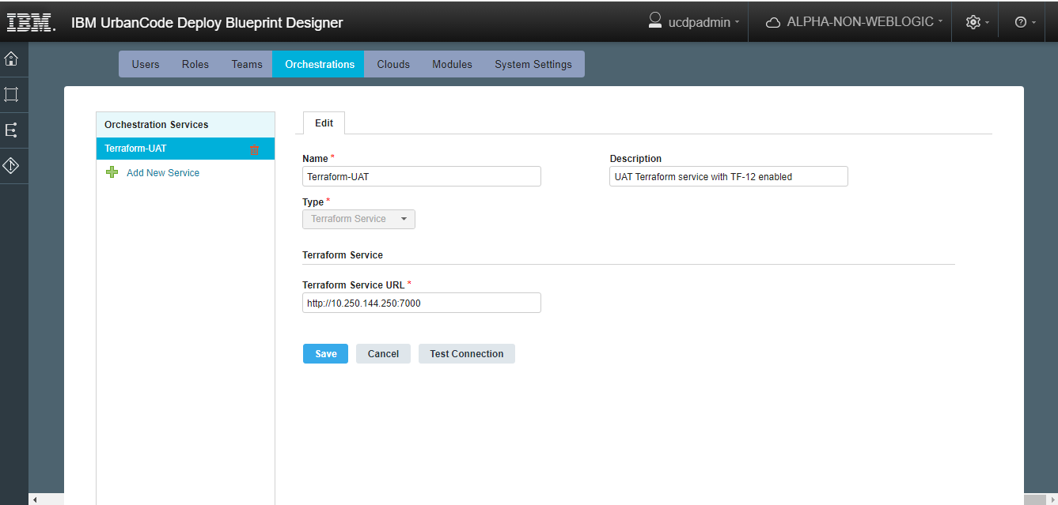

**6.5] Cloud Connections :**

**6.5.1] ALPHA-NON-WEBLOGIC**

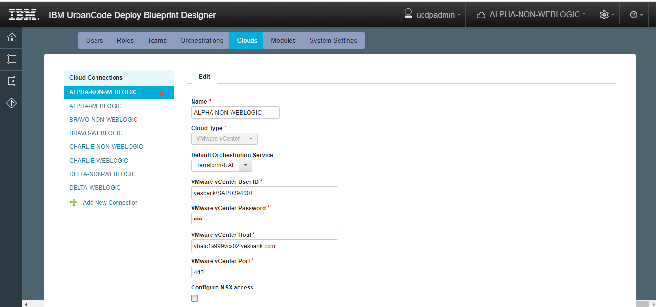

**6.5.2]vALPHA-WEBLOGIC**

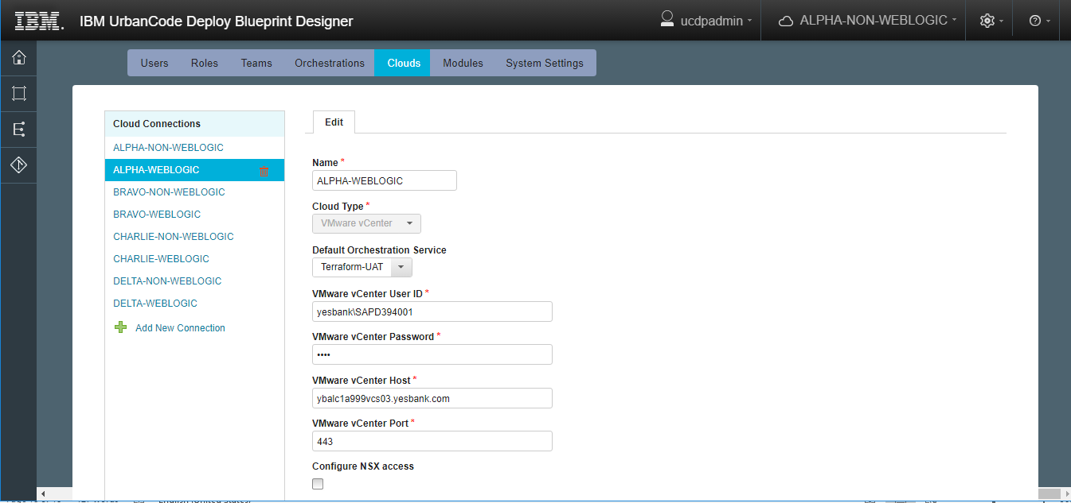

**6.5.3] BRAVO-NON-WEBLOGIC**

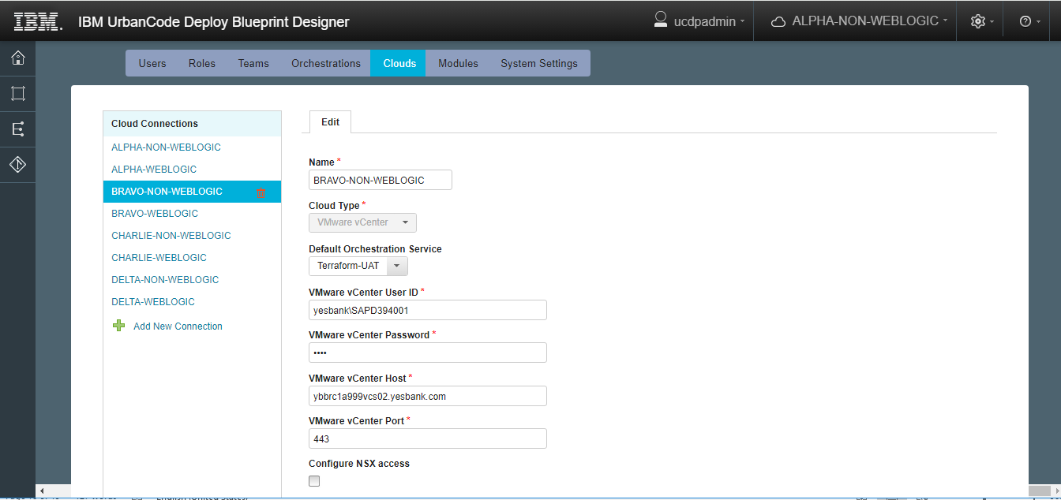

**6.5.4] BRAVO-WEBLOGIC**

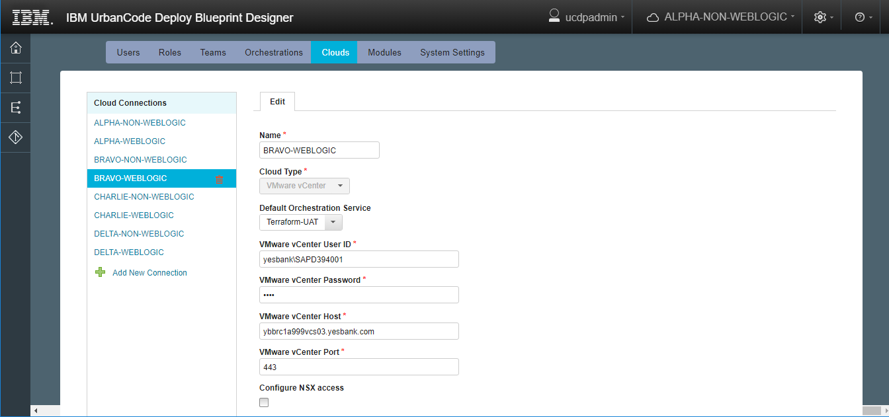

**6.5.5] CHARLIE-NON-WEBLOGIC**

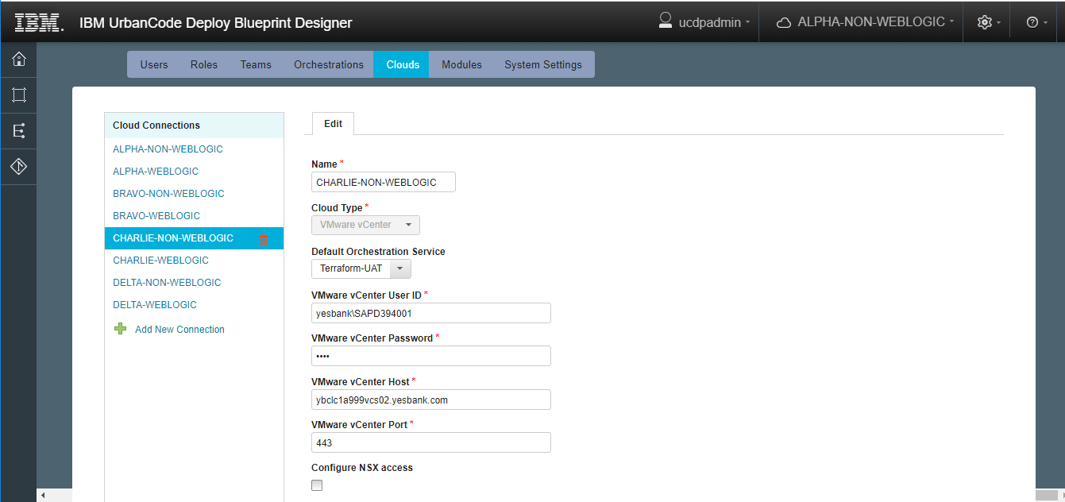

**6.5.6] CHARLIE-WEBLOGIC**

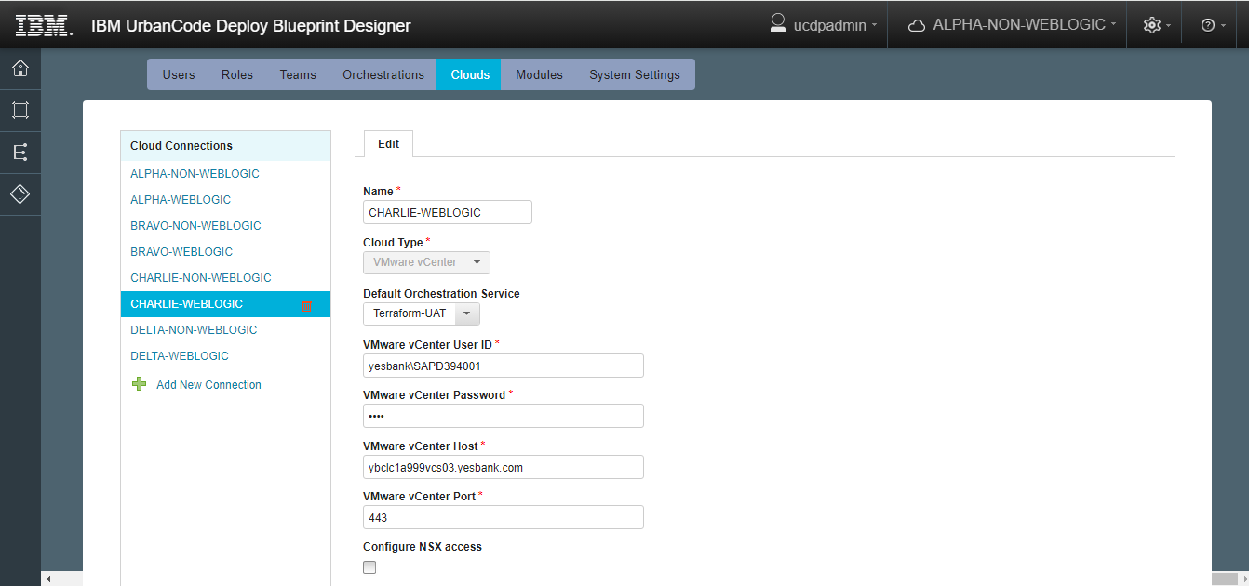

**6.5.7] DELTA-NON-WEBLOGIC**

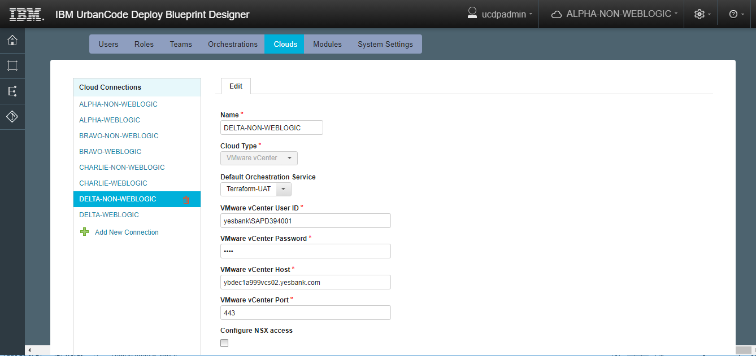

**6.5.8] DELTA-WEBLOGIC**

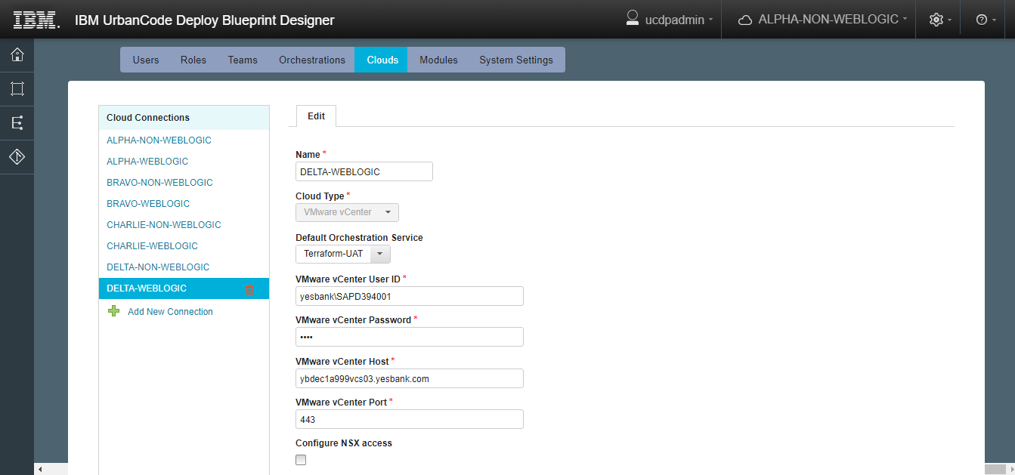

**6.6] Modules**

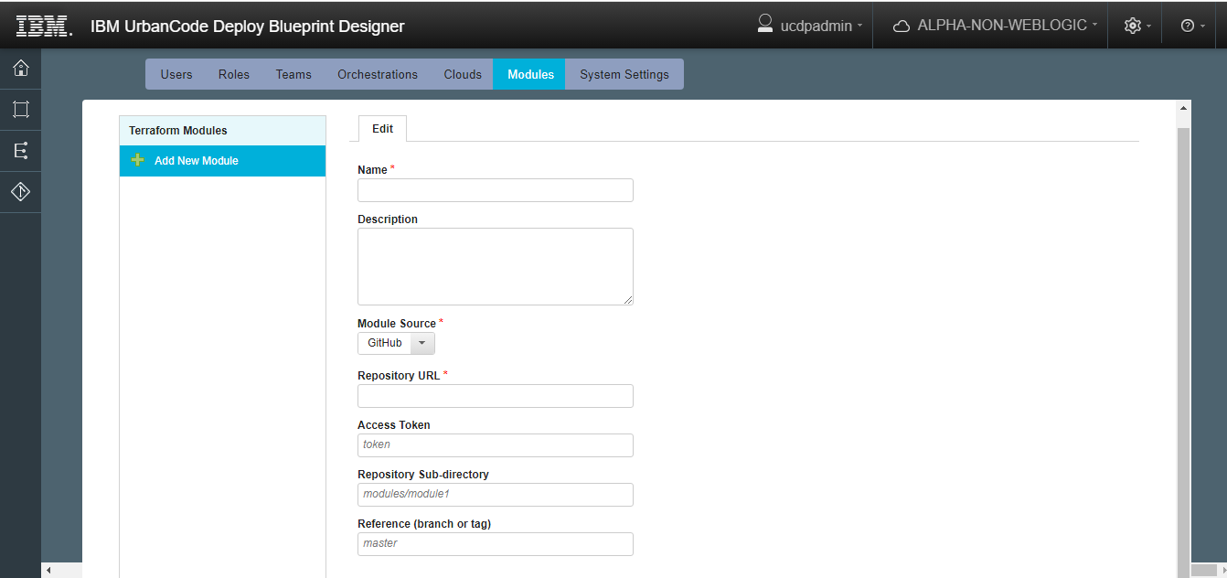

**6.7] System Settings**

